Personal info

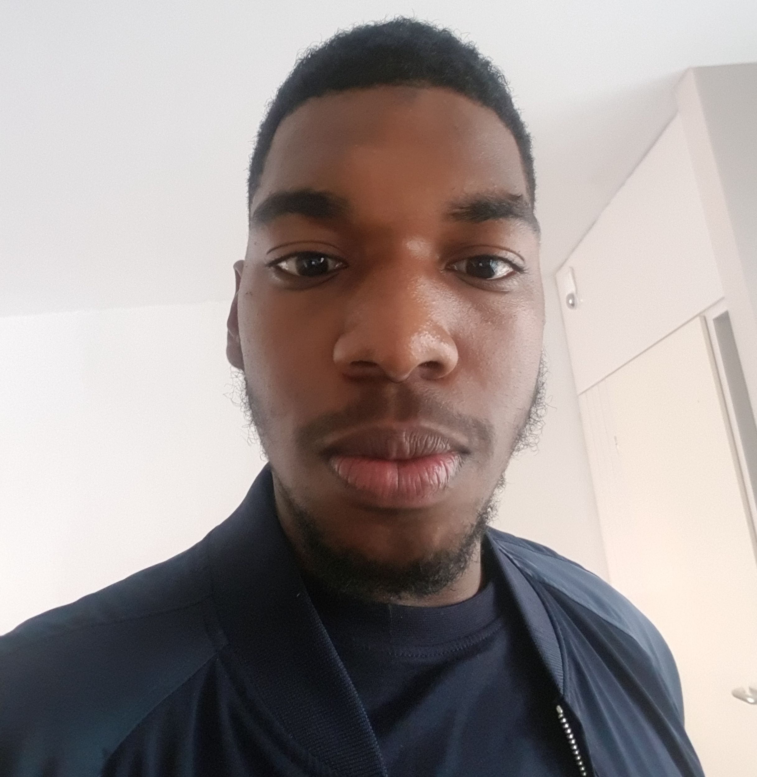

Surname: Gienoviere Demetrio Janga

Addres: Willem Van Noortlaan 31

5622 PL Eindhoven

Phone number: 06-20373275

Birth-date: 03-09-1999

Birth-place: Curaçao

Email: [ginojanga@gmail.com](mailto:ginojanga@gmail.com)

Website: https://gienoviere.github.io

Education

2021-2025 SintLucas, Software Development, Eindhoven

2019– 2021 Summa College ICT/programming, Eindhoven

Graduated March 2021

Work Experience

2025-2025 Malaga Jam, Spain

Joined the gamejam and made an game with the theme as bubbles. The game is on website and steam. It’s called shower thoughts.

2025-2025 Internship

2023-2023 Solvware, Waalwijk. Here I have to make websites, make web

applications, fix companies websites and automation

2023-2023 Malaga Jam, Spain. I did this 2 weeks in Spain. First week it was

building an app for a boss and last week was making a game in 3

days.

Technical Skills

* Unreal Engine 4/5

UE is my favoriet software to work with as that it has so many better things that Unity cant hope to have and I have been working with UE roughly 4 years.

* Unity

I have 5 years experience with Unity, I used this software before I did any software developement school as that I wanted to experience designen games and code the games.

* C++

I am learning this language less than a year now but am making good progress with it.

* C#

I have been working with C# for 4 years now

* HTML & CSS

I have 2 years experience with it and also used it to make my portfolio

* Javascript

Am still learning to work with but I have 1 year experience under the belt as, that I deem it important to know the language and is also used in my portfolio

* Blender

Am learning blender, because I find it very important as solo developer

* FL Studio

Why FL Studio on this list you might ask? Well I did learn work with FL Studio as that I loved creating beats and later di dit for creating music/sounds for the games. I owned FL Studio Signature bundle for 8 years now and occasionally make sounds or beats for fun. Not yet for the games.

|  |
| --- |
| Professional Skills |

* Amazing self-independence
* Great problem solving
* Excellent self-motivation
* Experience in game design/game engineering(coding)
* Deep knowledge of C#
* Professionalism
* Patience

Game Projects

* An RPG game in UE5 completely in C++
* Graphical programming in C++ as entry for BUAS. Breda University of Applied Science
* Pong

Made in 2020/21 as a starter project for school first grade

* FPS game

Made in 2021 as a schoolproject for a grade and also feedback to show how far i had progressed in learning to code the game and design in Unity.

* Race Game Pro

Made in 2020 with as a project for mini game con at school first grade.

* Running Game

Made as personal project because I wanted to make a similair subway surfer game, it’s not finished yet but I am certain i twill be finished in a year.

* RPG UE5

A personal project that I am working on, with this project am i learning to work with Unreal Engine 5 and also learning to code with C++ and blueprints. And also aiming to learn to make a RPG game.

* Gamejam

I made an game in 3 days with spanish students in malaga, spain. I was the sole developer of the game and they were designers, audio and scrummer

Miscellanous

Favorite Games/Studio’s:

Bethesda: The Elder Scroll V: Skyrim AE, Starfield, Fallout 4, Elder Scroll Online, Doom Eternal.

Xbox Game Studio’s: Halo 2/Halo Infinite/Halo Combat Evolved, Gears Of War series, COD Modern Warfare classic series (2,3) /reboot series

League of Legends, The Witcher III, Hades, GTA San Andreas, AC Oddysey, Final fantasy 7, 2 Final Fantasy 15, Cyberpunk, Tekken 7, Ghost Recon Breakpoint, Elden Ring, Warframe, The Division, Control, The Medium, AC Black Flag, Ghost Of Tsushima, Miles Moralis, Lego DC Supervillains, Batman Arkham series, DC Universe Online, Injustice 2, The first descendants, Suicide Squad Kill the Justice league.